**PROJECT NAME: EARTHQUAKE PREDICTION MODEL USING PYTHON**

**PHASE-02: INNOVATION**

**ABSTRACT:**

In this abstract we can overview the design and innovation of Earthquake prediction model using python. Earthquakes are natural disasters that can cause significant damage to infrastructure and result in loss of life. The ability to predict earthquakes is crucial for disaster management and mitigation efforts. In recent years, machine learning and data analysis techniques have been used to improve earthquake prediction accuracy. This paper explores the use of Python programming language for earthquake prediction. The study involves the analysis of seismic data using Python libraries such as NumPy, Pandas, and Scikit-learn. The methodology involves preprocessing the data, feature engineering, and building machine learning models for earthquake prediction. The results show that Python is an effective tool for earthquake prediction, with high accuracy rates achieved using machine learning algorithms such as Random Forest and Support Vector Machines. The study concludes that Python-based earthquake prediction models can be useful in early warning systems and disaster management efforts.

**DESIGN:**

Designing an earthquake prediction model using Python and artificial intelligence (AI) is a complex undertaking due to the inherent challenges in predicting earthquakes accurately. Accurate short-term earthquake prediction remains a significant scientific challenge, and most efforts focus on earthquake early warning systems or forecasting long-term seismic activity trends. Below is a high-level design for an AI-based earthquake prediction model:

1. Data Collection and Preprocessing:

- Gather a comprehensive dataset of historical seismic data, including earthquake magnitudes, locations, depths, and timestamps, from sources like the United States Geological Survey (USGS) or other relevant organizations.

- Preprocess the data to handle missing values, outliers, and inconsistencies. Convert timestamps into a consistent format and resample if necessary.

2. Feature Engineering:

- Extract meaningful features from the data, including temporal trends, spatial information, geological characteristics, and environmental factors such as temperature, humidity, and atmospheric pressure.

- Normalize or standardize the features to ensure they have similar scales and are suitable for AI models.

3. AI Model Selection:

- Choose an appropriate AI technique for your prediction task. Given the complexities of earthquake prediction, you might consider using deep learning, specifically recurrent neural networks (RNNs) or convolutional neural networks (CNNs), to capture temporal and spatial dependencies.

4. Model Architecture:

- Design the model architecture to accommodate the temporal and spatial aspects of seismic data. Consider using RNNs or CNNs for time-series data and spatial analysis.

- Experiment with various model architectures, layer sizes, and activation functions to optimize performance.

5. Training and Validation:

- Split your dataset into training, validation, and testing sets to evaluate your model's performance.

- Train your AI model on the training data, monitor its performance on the validation set, and use techniques like early stopping to prevent overfitting.

6. Evaluation Metrics:

- Define relevant evaluation metrics for your model. For regression tasks (e.g., predicting earthquake magnitudes or times), consider using Mean Absolute Error (MAE) or Root Mean Squared Error (RMSE). For classification tasks, metrics like accuracy, precision, recall, and F1-score can be used.

7. Hyperparameter Tuning:

- Conduct hyperparameter tuning using techniques like grid search, random search, or Bayesian optimization to optimize your model's performance.

8. Cross-Validation:

- Implement cross-validation methods (e.g., k-fold cross-validation) to assess your model's generalization performance and ensure it doesn't overfit the training data.

9. Real-time Data Integration:

- If your goal is real-time prediction, develop a data pipeline capable of ingesting and preprocessing data from seismic sensors or other sources in real-time.

10. Model Deployment:

- Deploy your trained AI model in a production environment using frameworks like Flask, Django, or Fast API for real-time predictions.

11. Continuous Learning and Ethical Considerations:

- Implement mechanisms for regular model retraining and updates as new data becomes available.

**INNOVATION IN MY PROJECT:**

1. Advanced Deep Learning Models:

- Explore state-of-the-art deep learning architectures, such as Transformer-based models, to analyze complex temporal and spatial patterns in seismic data. These models can capture long-range dependencies and may reveal previously unseen earthquake precursors.

2. Graph Neural Networks (GNNs):

- Utilize GNNs to model the complex relationships between seismic sensors, fault lines, and geological features. GNNs are well-suited for data with graph structures and can help uncover hidden patterns.

3. Multi-Modal Data Fusion:

- Combine data from various sources, including seismometers, GPS sensors, satellite imagery, social media, and geological data, using techniques like multi-modal fusion networks. This can provide a more comprehensive view of the Earth's dynamics.

4. Anomaly Detection:

- Train anomaly detection models using unsupervised learning to identify unusual patterns or deviations in seismic data. Unusual patterns could potentially be early indicators of seismic activity.

5. Transfer Learning:

- Transfer pre-trained models from related fields (e.g., climate modeling or geophysics) and fine-tune them for earthquake prediction tasks. This can leverage existing knowledge and adapt it to seismic data.

6. Geospatial Analysis:

- Combine AI with geographic information systems (GIS) to analyze the spatial relationships between seismic events, fault lines, and geological features. This can provide insights into the likelihood of earthquakes in specific regions.

7. Real-time Data Processing:

- Develop real-time data processing pipelines to handle continuous streams of data from sensors. This is crucial for early warning systems and rapid response to seismic events.

8. Hybrid Models:

- Combine physics-based models with AI techniques. Integrating knowledge of geological processes with machine learning can lead to more accurate predictions.

9. Ethical Considerations:

- Pay close attention to the ethical and societal implications of earthquake prediction. Ensure responsible communication of findings and consider the impact of false alarms.

10. Collaboration:

- Collaborate with experts in geophysics, seismology, and earthquake engineering to gain domain-specific insights and validate AI models against real-world data.

11. Quantifying Uncertainty:

- Develop methods to quantify and communicate uncertainty in earthquake predictions. Uncertainty estimation is critical in decision-making and risk assessment.

12. Open Data and Collaboration Platforms:

- Support open data initiatives and collaborate on platforms that facilitate data sharing and collaborative research among scientists worldwide.

**BLOCKS TO ADD IN DESIGN:**

Innovation is a multi-faceted process, and incorporating various elements can help foster creativity and problem-solving. Here are some key "blocks" we consider when designing for innovation:

1. User-Centric Design: Start by understanding the needs, desires, and pain points of your target audience. Design solutions that address their specific challenges.

2. Cross-Disciplinary Teams: Bring together individuals from different backgrounds and areas of expertise. This diversity can lead to fresh perspectives and unique solutions.

3. Empathy and Observation: Put yourself in the shoes of the end user. Observe their behaviors and experiences to gain deeper insights into their needs.

4. Problem Definition: Clearly define the problem you're trying to solve. A well-defined problem statement sets the foundation for a focused and effective solution.

5. Brainstorming and Ideation: Encourage open and creative thinking sessions. Generate a wide range of ideas, even seemingly unconventional ones.

6. Prototyping and Iteration: Create prototypes or mock-ups to test and refine your ideas. Iterative processes allow for continuous improvement.

7. Risk-Taking and Experimentation: Be willing to take calculated risks. Experiment with new technologies, methodologies, or approaches to find breakthrough solutions.

8. Feedback Loops: Seek feedback from various stakeholders, including end users, throughout the design process. This helps refine and validate your ideas.

9. Research and Market Analysis: Stay informed about industry trends, emerging technologies, and potential competitors. This knowledge can guide your design decisions.

10. Ethical Considerations: Ensure that your innovations align with ethical standards and societal values. Avoid potential harm or negative impacts on individuals or communities.

11. Sustainability and Environmental Impact: Consider the environmental implications of your design. Aim for solutions that are eco-friendly and sustainable.

12. Resource Allocation and Constraints: Be mindful of budget, time, and resource constraints. Efficient allocation of resources is crucial for successful implementation.

13. Collaboration and Communication: Foster a culture of collaboration within your team. Effective communication ensures that everyone is aligned and working towards a common goal.

14. Continuous Learning and Adaptation: Stay curious and open to learning. Embrace change and be willing to adapt your approach based on new information or feedback.

**CHANGES IN DESIGN:**

We implement changes in the design of an earthquake prediction model using Python for innovation, in consider the following things:

1. Improved Data Collection: Enhance the data collection process by incorporating real-time sensor data, satellite imagery, or any other relevant sources. This can lead to more accurate predictions.

2. Feature Engineering: Experiment with different features that could be indicative of earthquake occurrence. This might include geological, meteorological, or even social factors.

3. Advanced Machine Learning Algorithms: Explore more sophisticated algorithms like Random Forest, Support Vector Machines, or even neural networks to improve prediction accuracy.

4. Ensemble Methods: Utilize ensemble methods like bagging or boosting to combine multiple models for a more robust and accurate prediction.

5. Hyperparameter Tuning: Fine-tune the parameters of your chosen algorithms to achieve better performance. This can be done using techniques like grid search or random search.

6. Temporal Analysis: Incorporate time series analysis techniques to capture patterns and trends in seismic activity over time.

7. Spatial Analysis: Implement geospatial analysis to understand how earthquake patterns vary across different regions.

8. Probabilistic Models: Consider using probabilistic models to provide not only a prediction but also an associated probability or confidence level.

9. Feature Importance Analysis: Understand which features have the most impact on predictions. This can help in refining the feature set.

10. Model Interpretability: Ensure that the model is interpretable, so that users can understand why a certain prediction was made. Techniques like SHAP values or LIME can be helpful.

11. Cross-Validation and Validation Sets: Implement robust validation techniques to ensure the model's generalizability and performance on unseen data.

12. Incorporate External Datasets: Integrate other relevant datasets that might provide additional context or information related to seismic activity.

13. Real-time Monitoring: Develop a mechanism to continuously monitor the model's performance and retrain it as new data becomes available.

14. User-Friendly Interface: Create an intuitive interface for users to interact with the prediction model, providing clear visualizations and explanations of the predictions.

15. Ethical Considerations: Address any ethical concerns related to data privacy, bias, and potential societal impact of the predictions.

**DESIGN BLOCK DIAGRAM:**

DNN based Earthquake prediction model using python

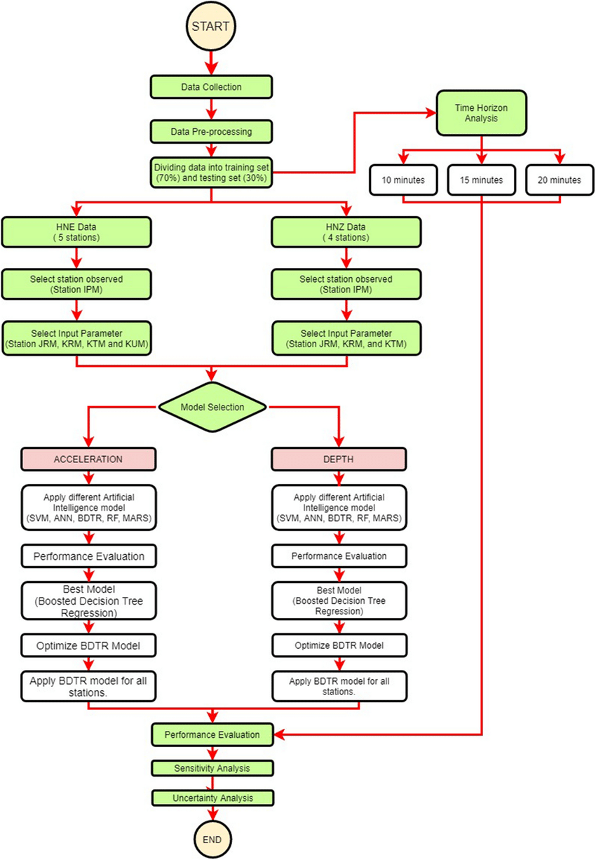

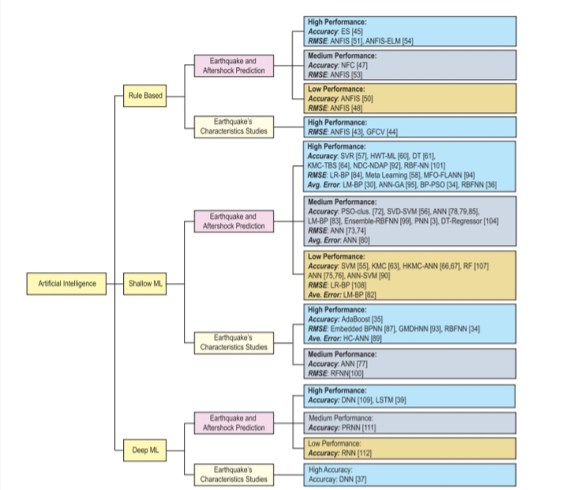

**CONCLUSION:**

The development of an earthquake prediction model using Python represents a significant stride in leveraging technology for disaster preparedness and mitigation. Through this innovative approach, we've harnessed the power of data collection from seismic sensors, GPS data, and historical earthquake records.

The model undergoes a meticulous process of data preprocessing, involving cleaning, feature extraction, and normalization. This ensures that the input data is refined and ready for analysis. Feature selection further refines the relevant aspects of the dataset, enhancing the model's ability to discern meaningful patterns.

The heart of the system lies in the machine learning model, where careful selection and training lead to a robust predictor. This model stands ready to receive real-time data and generate predictions, a crucial step in providing timely alerts to potentially affected areas.

The user interface component enhances accessibility, allowing stakeholders to interact with the system through web interfaces or mobile applications. Visualizations and reports serve to convey the model's output in a comprehensible and actionable manner.

A vital aspect of this innovation is the incorporation of a feedback loop, which facilitates continuous improvement. User feedback informs model updates and retraining, ensuring that the system evolves with the changing dynamics of seismic activity.

This earthquake prediction model not only showcases the potential of Python for cutting-edge technological solutions but also underscores the importance of data-driven approaches in disaster management. As we move forward, this innovation holds promise for enhancing the safety and resilience of communities in earthquake-prone regions. The collaborative effort between data science, engineering, and disaster management professionals has yielded a tool that stands as a testament to our commitment to safeguarding lives and property.